**Lab No :14**

**Accuracy/Loss and Confusion Matrix plots:**

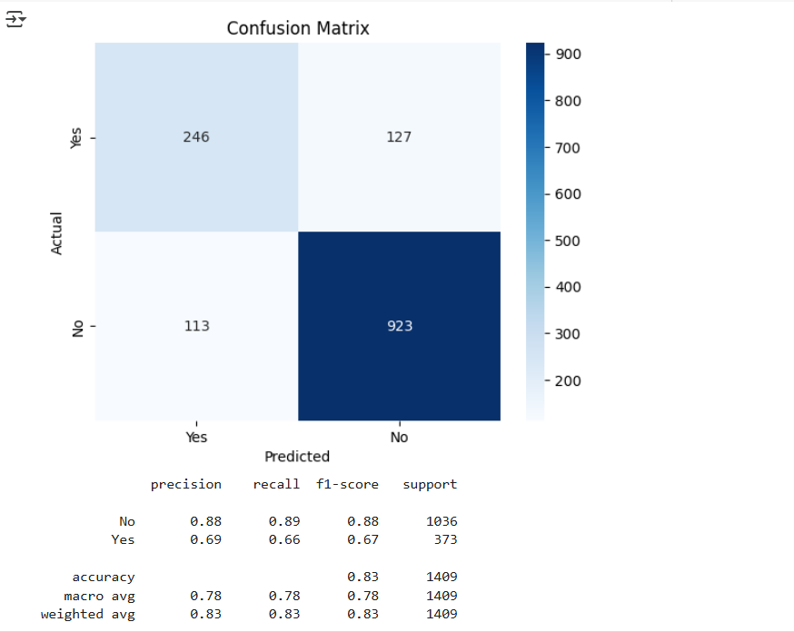 **Prediction + business action for 5 customers:**

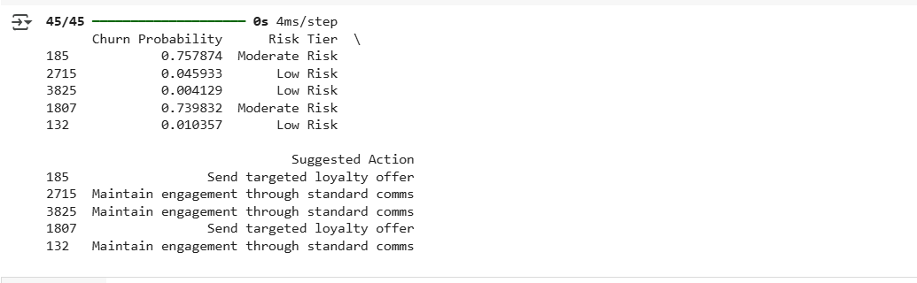

**Table/chart comparing different model settings:**

